VPC Task – 01

- Create VPC with 2 private and 2 public subnets.
Create VPC
Open AWS Console → VPC → Your VPCs → Create VPC
Select: VPC Only
Enter values:
    - Name: my-vpc-01
    - IPv4 CIDR: 172.168.0.0/16
    - DNS hostnames Enable
    - Leave others default
Click Create VPC
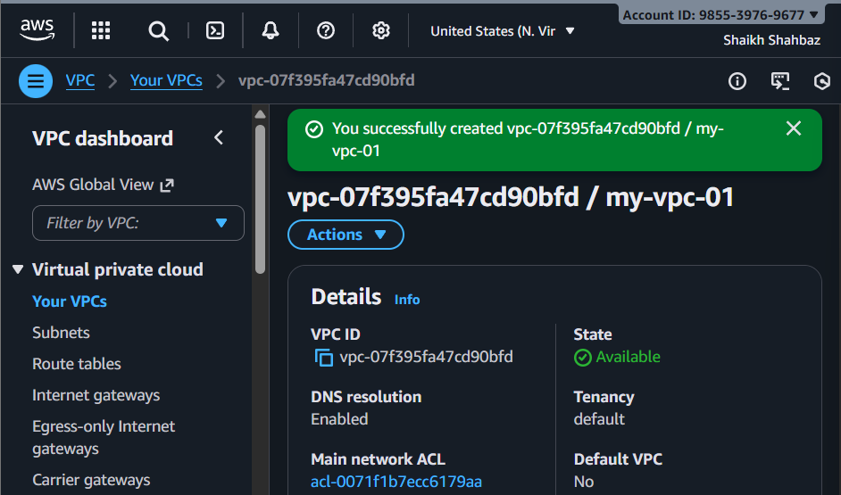
Create Subnets
We will create 4 subnets inside the VPC.
🔹 Public Subnet 1
- Go to Subnets → Create subnet
- Select VPC: my-vpc-01
- Subnet name: Public-Subnet-01
- AZ: eu-east-1a
- IPv4 CIDR block: 172.168.0.0/26
- Click Create subnet
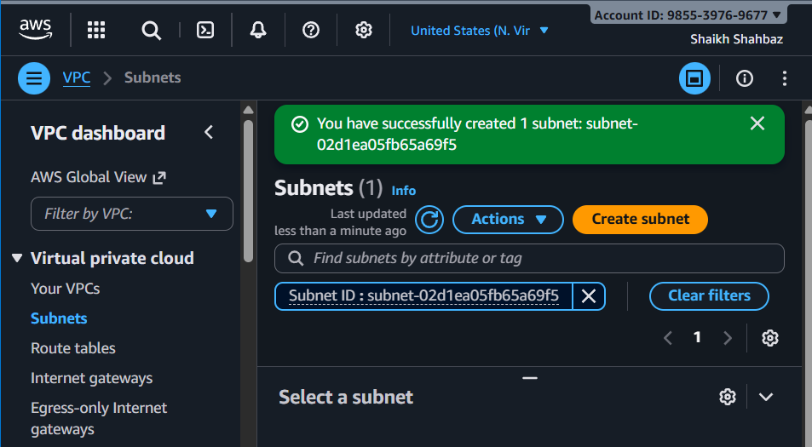
🔹 Public Subnet 2
- Subnet name: Public-Subnet-02
- AZ: eu-east-1b
- CIDR: 172.168.0.64/26
- Create
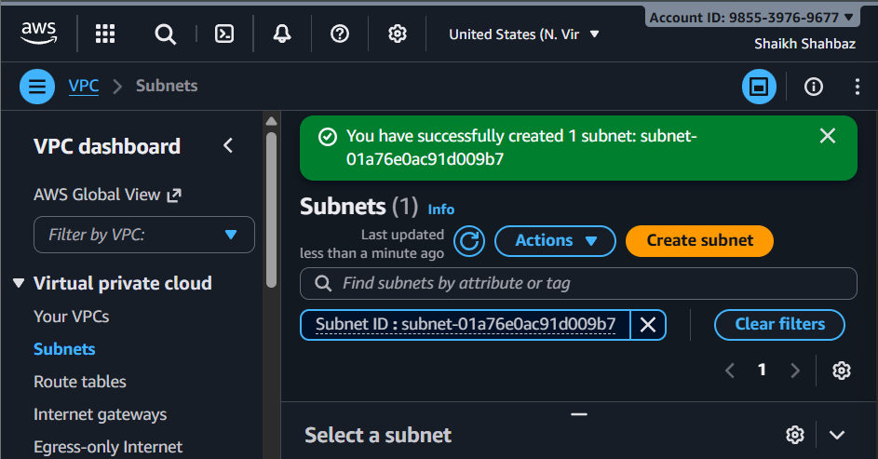

🔹 Private Subnet 1
- Subnet name: Private-Subnet-01
- AZ: eu-east-1a
- CIDR: 172.168.0.128/26
- Create
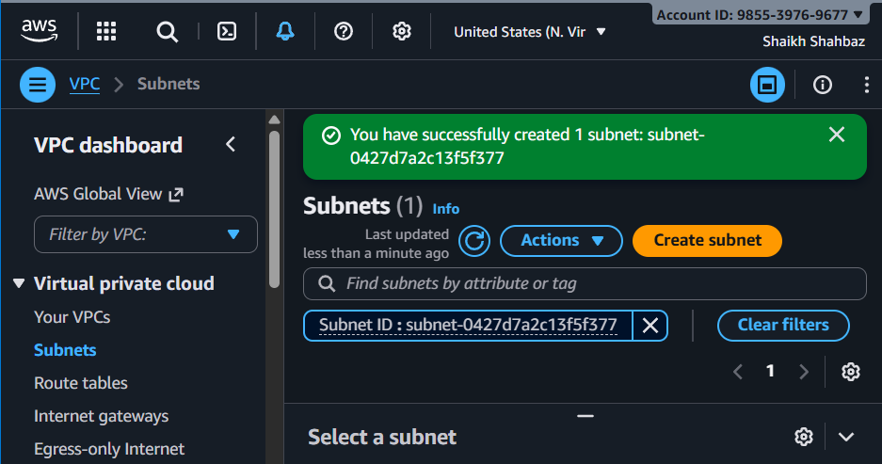
🔹 Private Subnet 2
- Subnet name: Private-Subnet-02
- AZ: eu-east-1b
- CIDR: 172.168.0.192/26
- Create
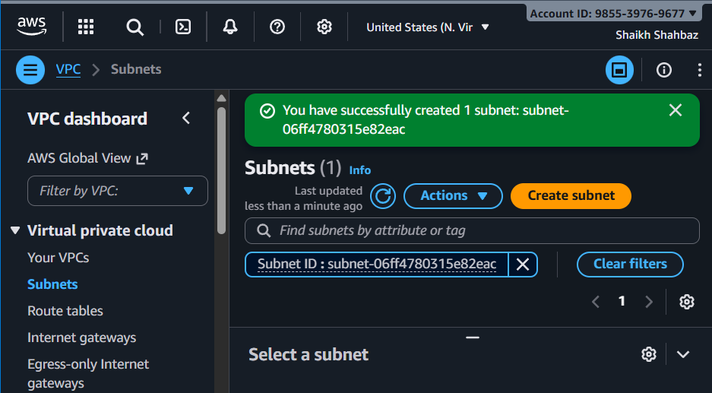
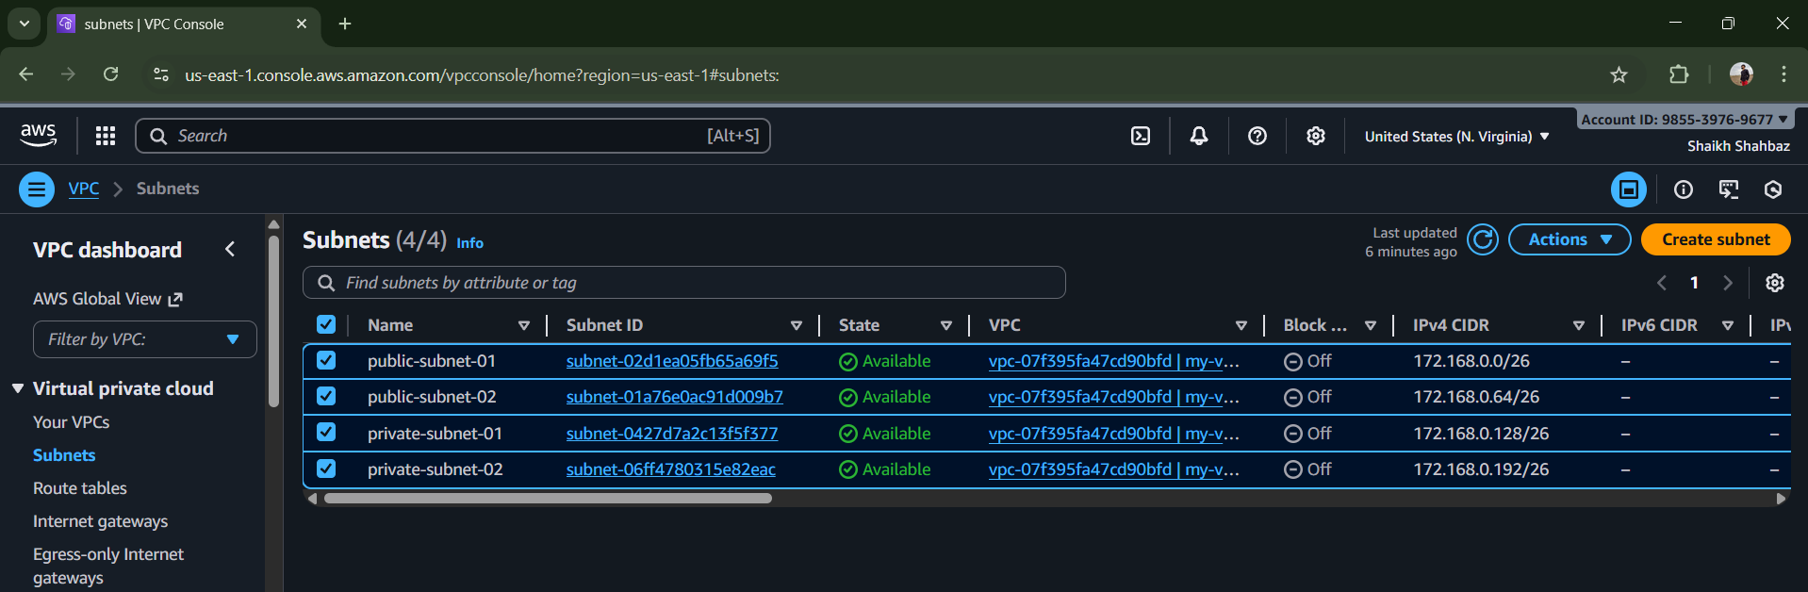
- Enable DNS Hostname in VPC.
Go to your VPCs
Select my-vpc-01
Click actions Edit DNS hostnames
Enable : DNS Hostnames
Save changes
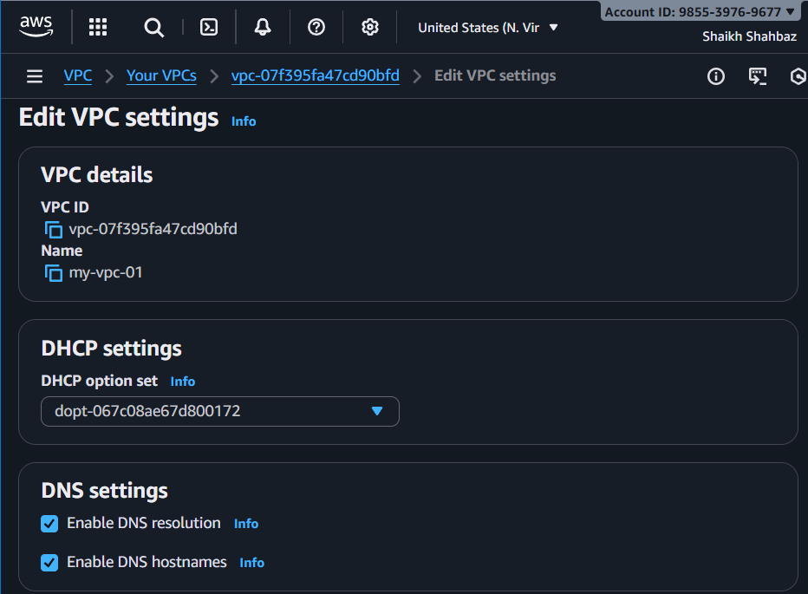
- Enable Auto Assign Public IP in 2 public subnets.
Go to Subnets
Select public-subnet-01
Click Actions Edit subnet settings
Enbale : Auto-assign IPv4 public IP
Save
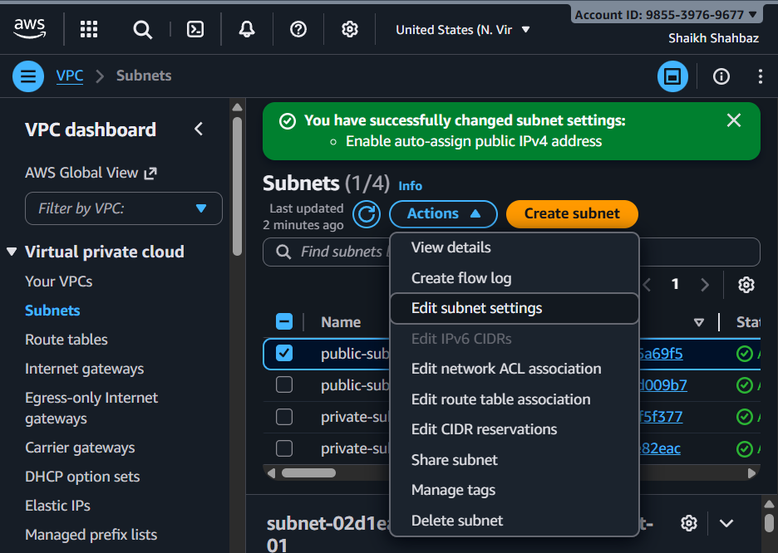
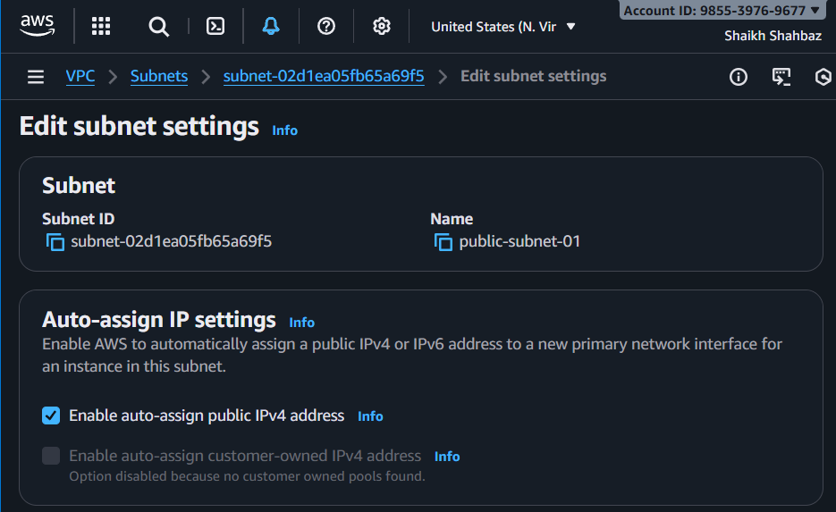
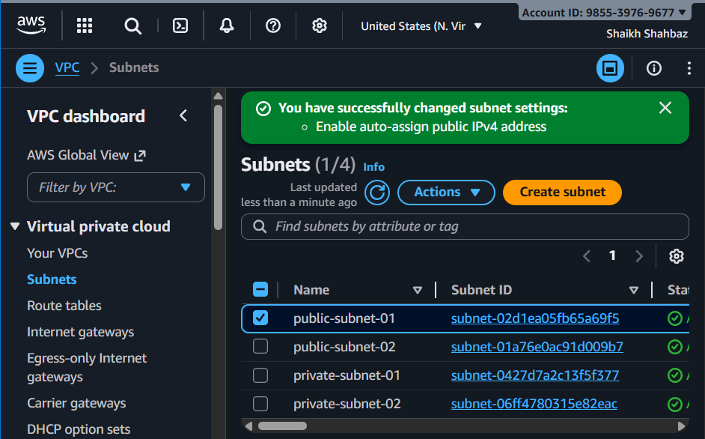
Go to Subnets
Select public-subnet-01
Click Actions Edit subnet settings
Enbale : Auto-assign IPv4 public IP
Save
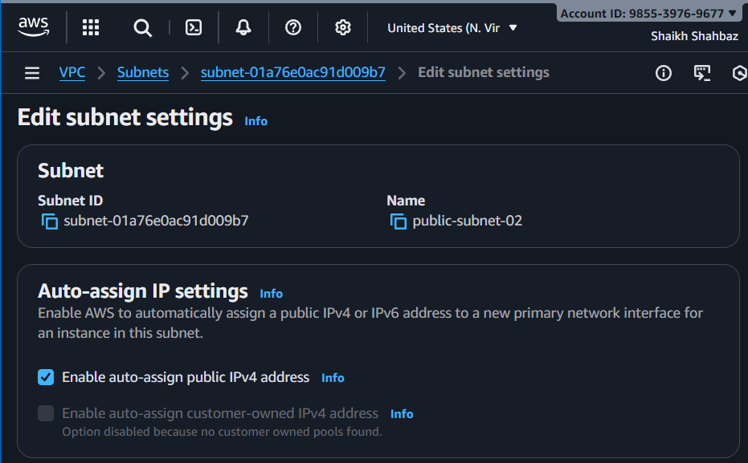
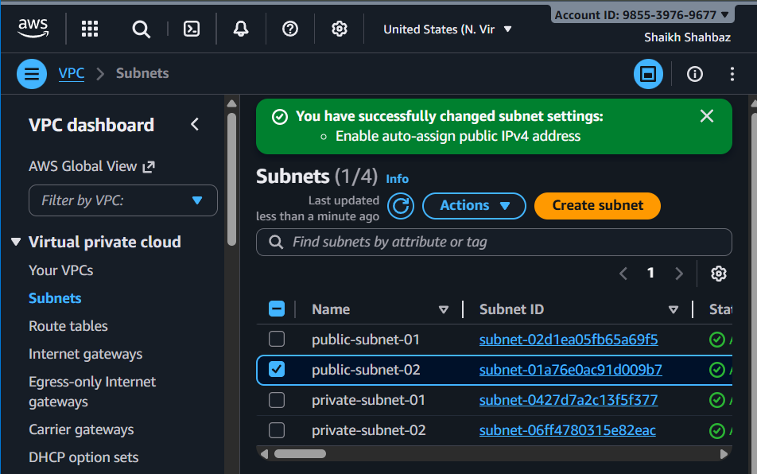
- Add 2 private subnets in private route table.
Go to Route Tables Create route table
Name : private-RT
Choose VPC : my-vpc-01
Create
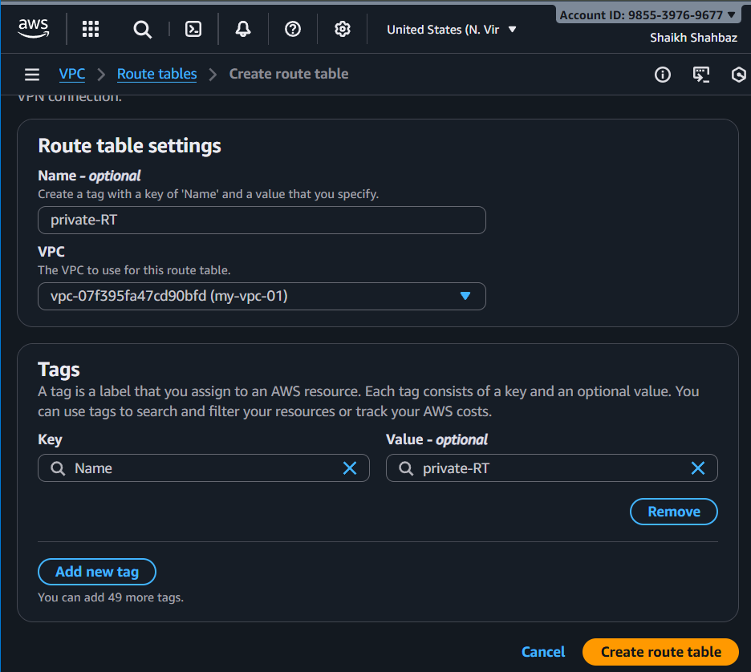
Now associate
Select private-RT Subnet association Edit
Select : private-subnet-01
Private-subnet-02
Save association
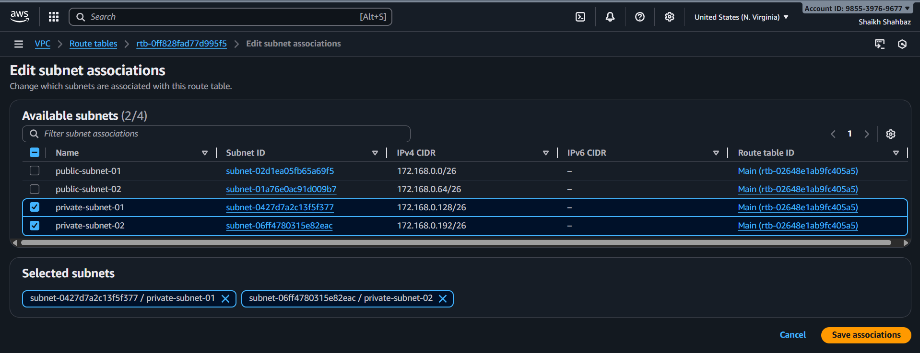
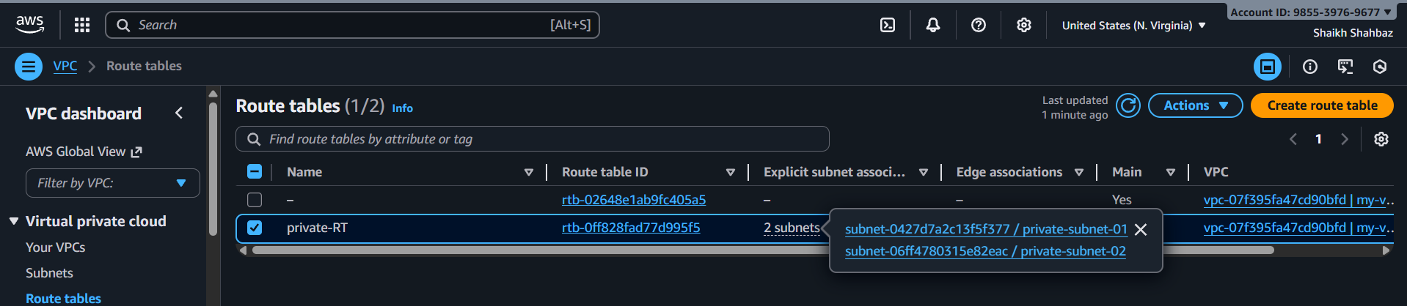

- Add 2 public subnets in public route table.
Route Tables Create route table
Name : public-RT
VPC : my-vpc-01
Create
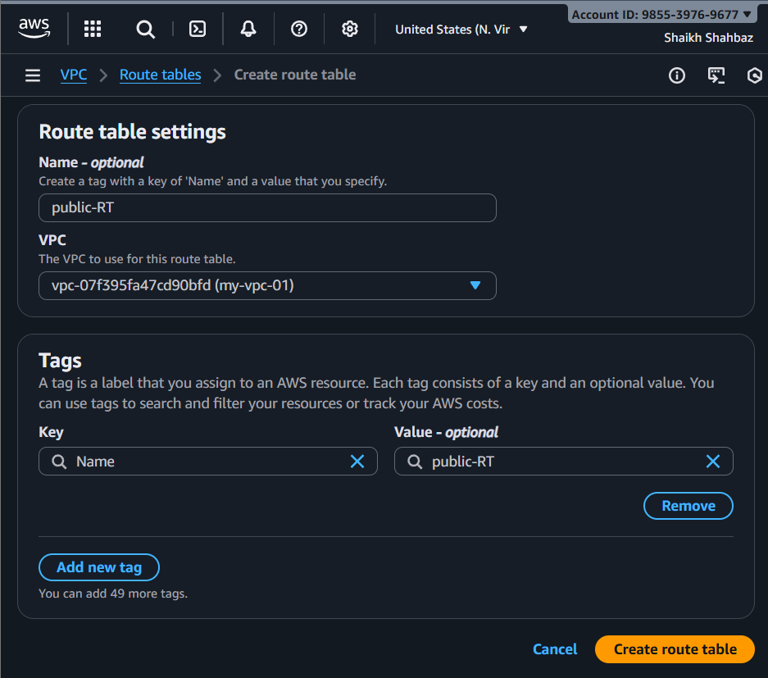
Associate
Select public-RT Subnet association Edit
Select : public-subnet-01
Public-subnet-02
Save
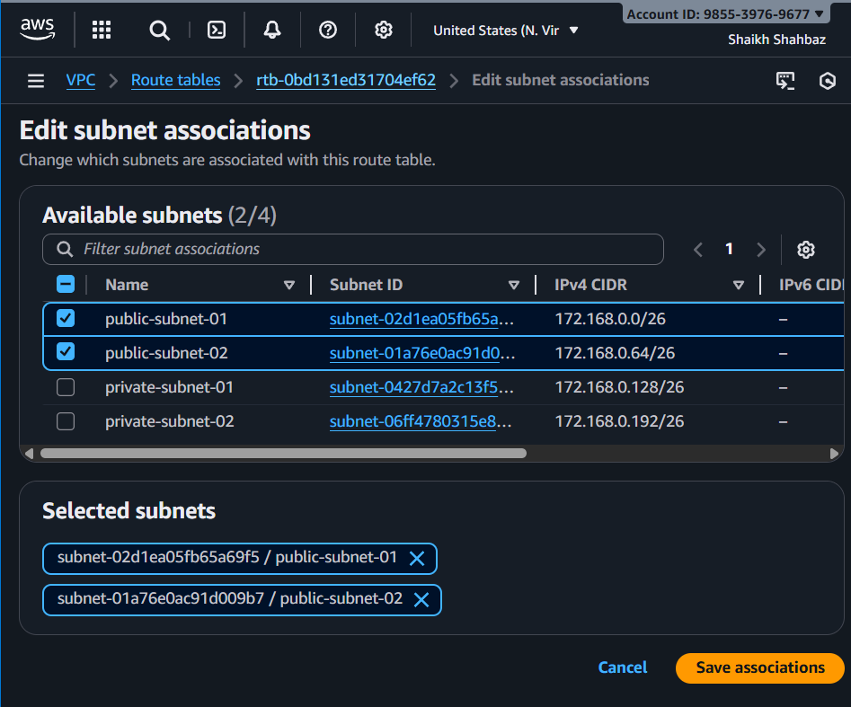
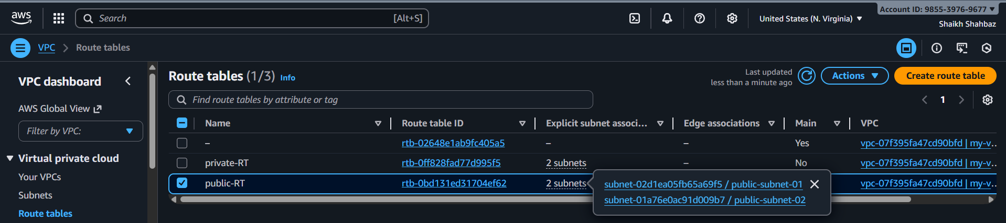

- Public route table will have the routes to internet and local.
Go to Internet Gateways Create IGW
Name : my-igw
Create Actions Attach to VPC
Select my-vpc-01
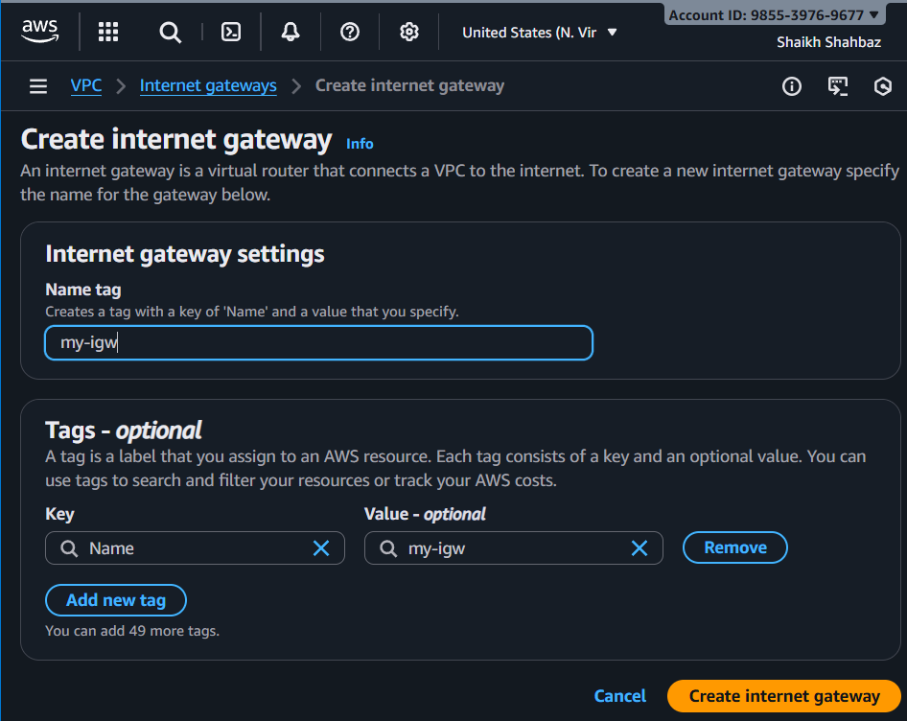
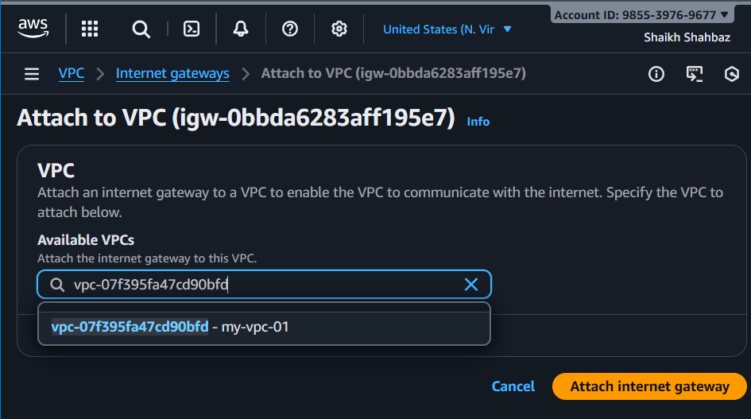

Add route to Public Route Table
Select public-RT
Routes Edit routes
Add : Destination : 0.0.0.0/0
Target : Internet Gateway (my-igw)
Save
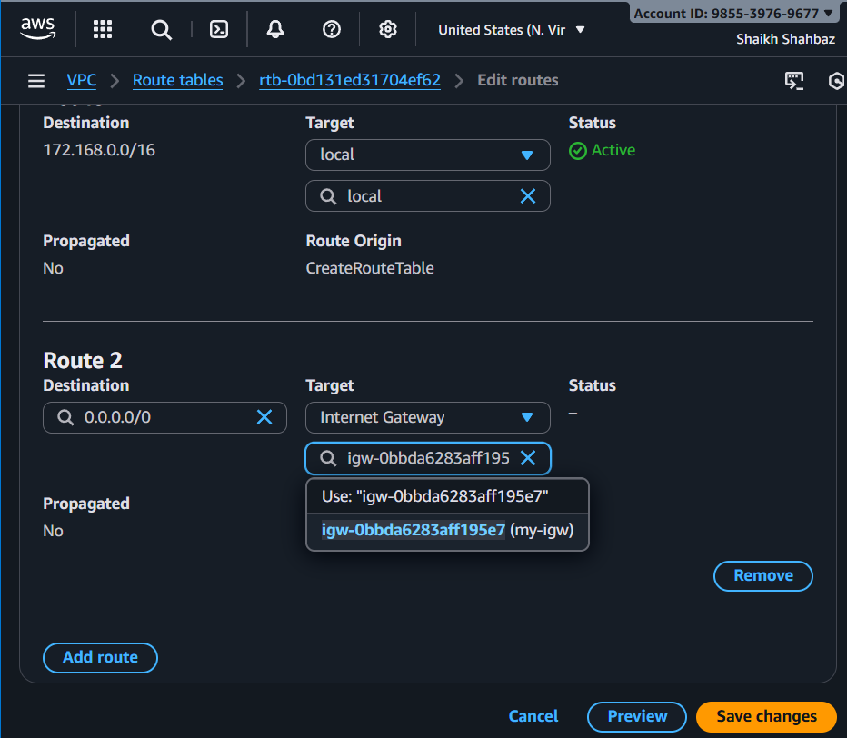

- Create EC2 in public subnet with t2.micro and install PHP.
Go to ec2 Launch Instance
Name : public-server
AMI : Amazon Linux 2
Instance type : t2.micro
Key pair : select existing (avengers)

Network :
VPC : my-vpc-01
Subnet : public-subnet-01
Auto-assign public IP : Enabled
Security group :
Allow SSH (22)
Allow HTTP (80)
User data : #!/bin/bash
yum update -y
yum install -y httpd php
systemctl start httpd
systemctl enable httpd
echo "<?php phpinfo(); ?>" > /var/www/html/index.php
Launch Instance
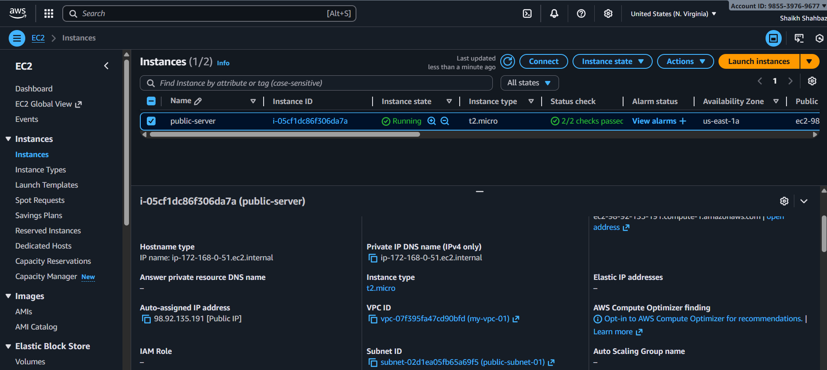
Test in browser : https:// 98.92.135.191
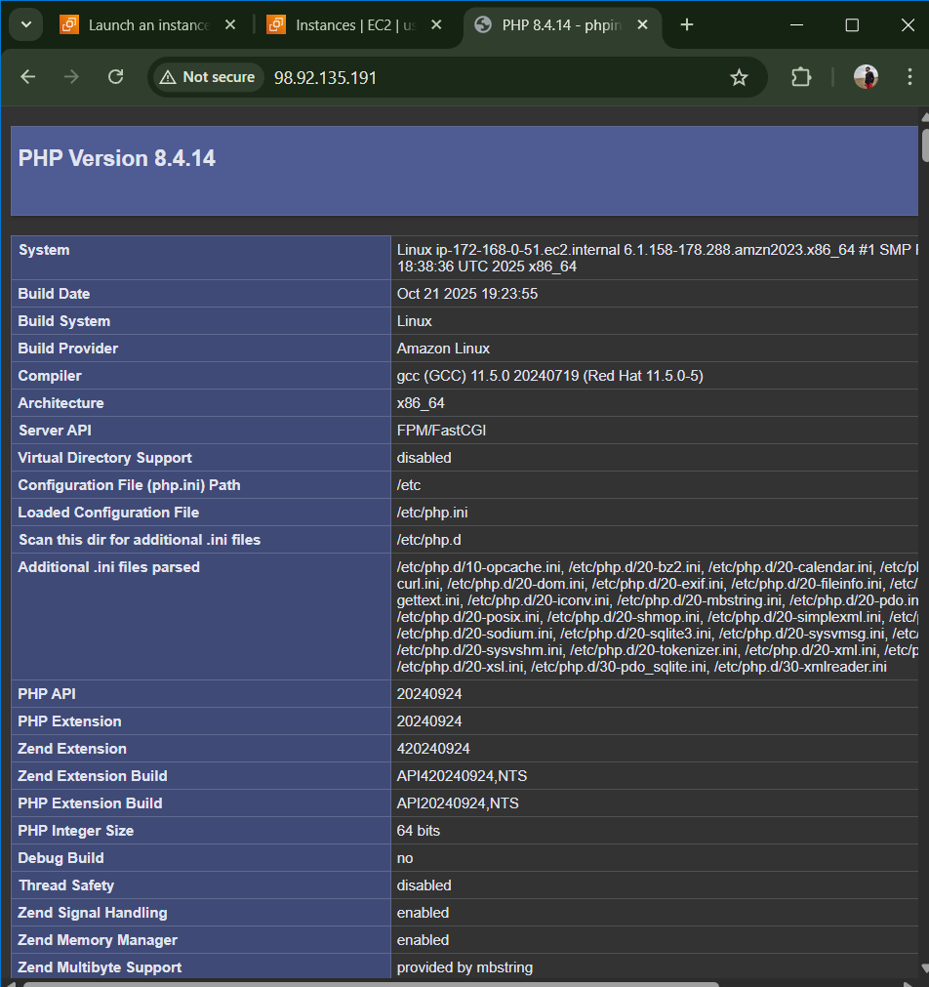

- Configure NAT gateway in public subnet and connect to private instance.
Go to Elastic IPs Allocate Elastic IP
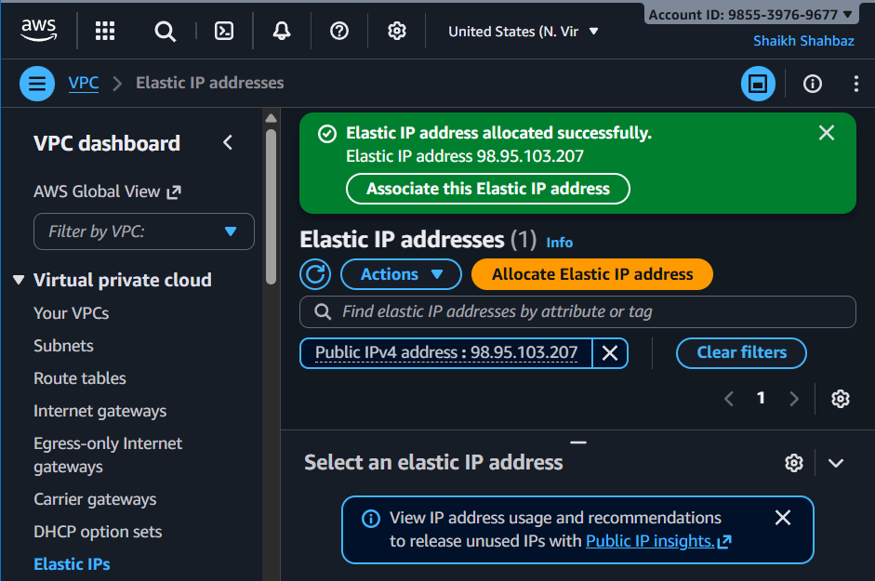
Go to NAT Gateway Create NAT Gateway
Name : my-nat
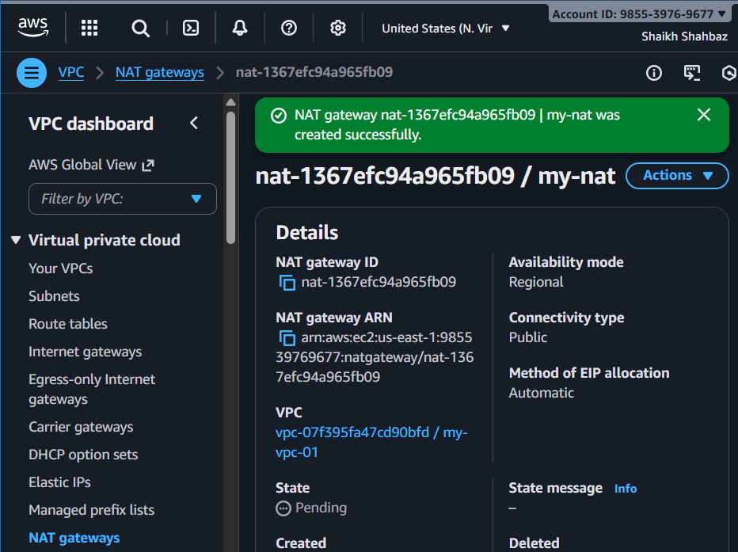
Subnet : public-subnet-01
Elastic IP : Select allocated
Create
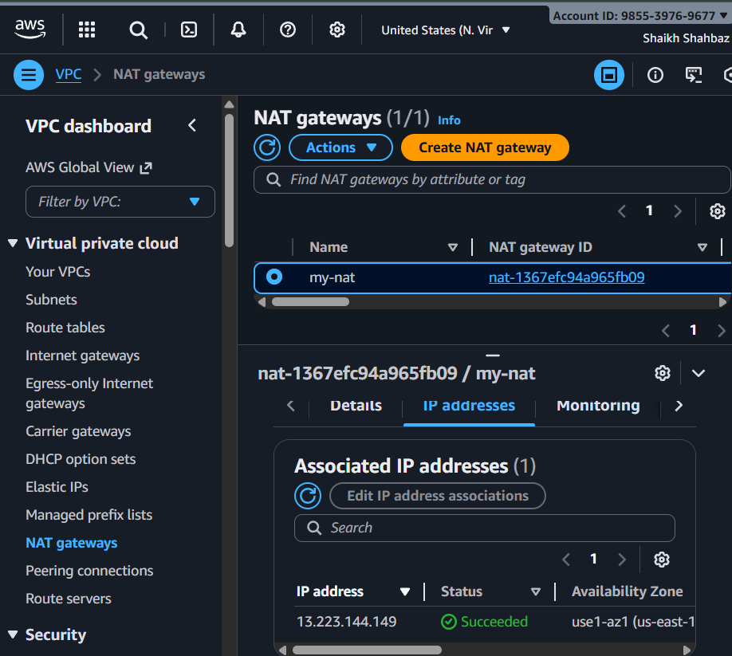
Update Private Route Table
Route Tables private-RT
Routes Edit routes Add : Destination : 0.0.0.0/0
Target : NAT Gateway my-nat
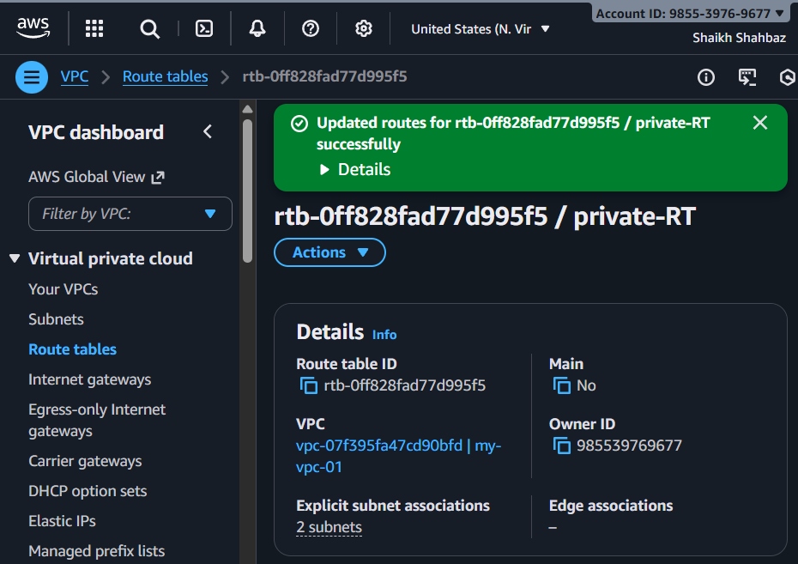
Now private servers can access the internet
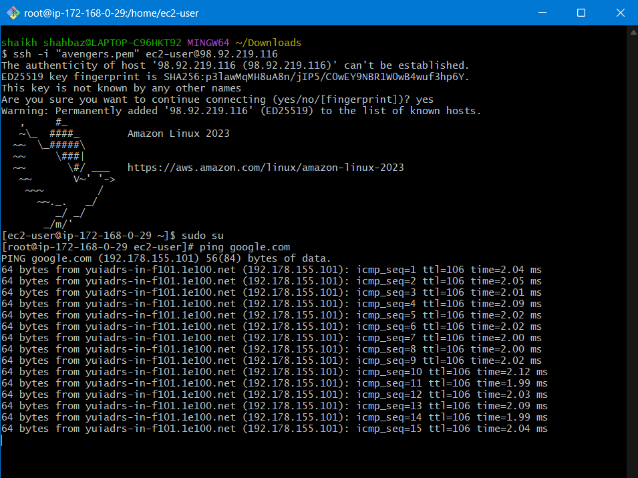

- Install Apache Tomcat in private EC2 and deploy a sample app.
Launch Private ec2 (Tomcat Server)
Ec2 Launch instance
Name : private-tomcat
AMI : Amacon Linux 2
Instance type : t2.micro
Key pair : avengers.pem (select exixting)
VPC : my-vpc-01
Subnet : public-subnet-01
Auto Assign Public IP : Disabled
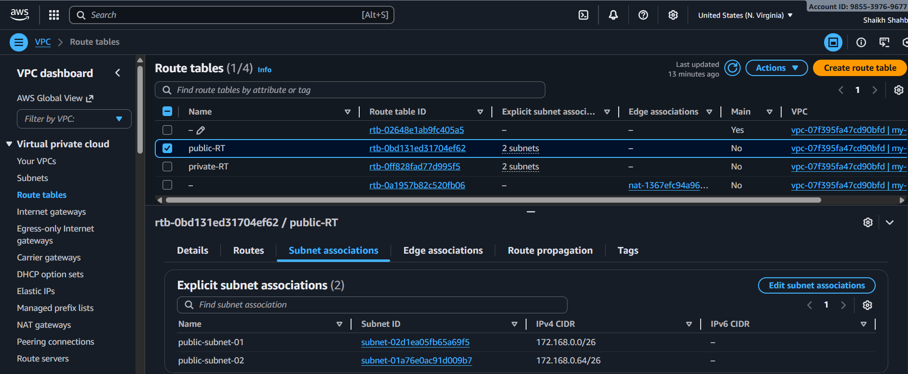
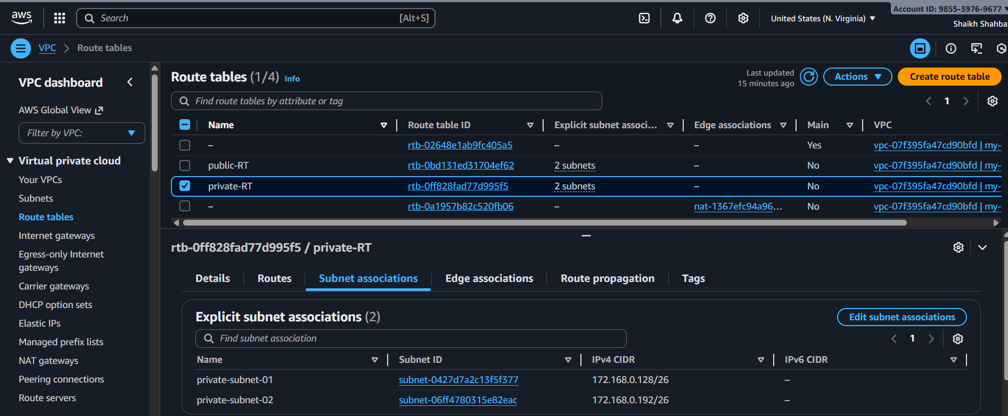
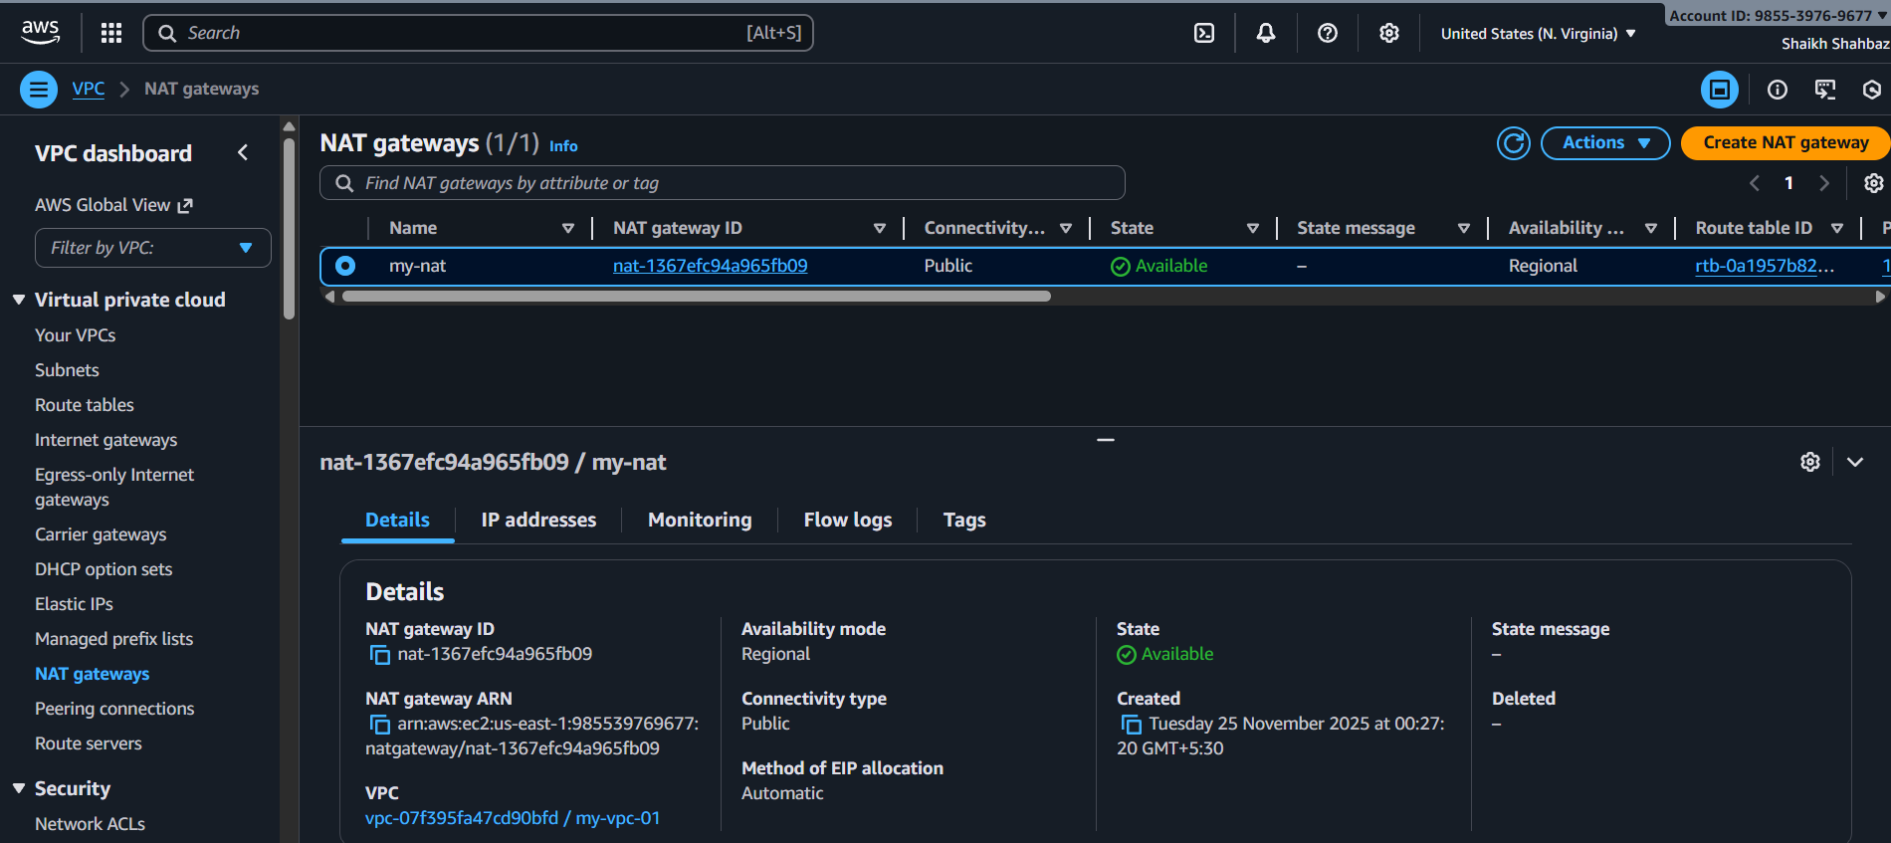
Security Group : SSH only from internal VPC (10.0.0.0/16)
Tomcat Port (8080) allow internal network only
SSH into Private ec2 via Public ec2
From laptop ssh into public server : ssh -I “avengers.pem” ec2-user@<public-ip>
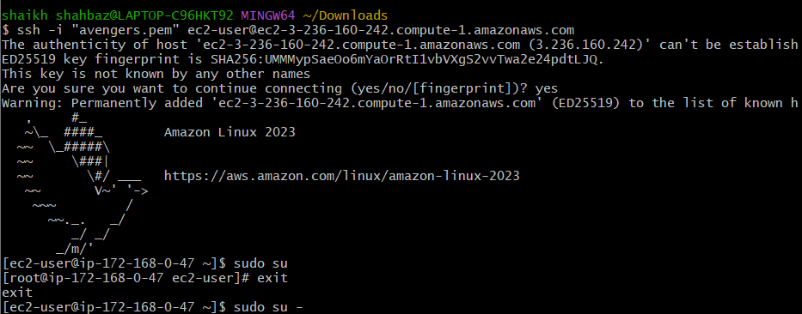
Then from public to private : ssh -I “avengers.pem” ec2-user@<private-ip>
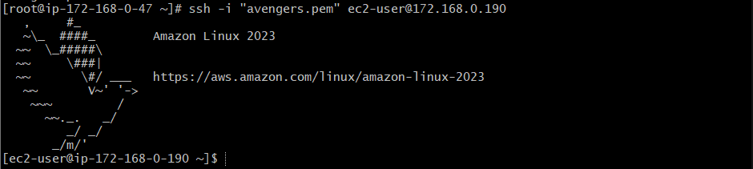
Install java and tomcat on private ec2
sudo yum update -y
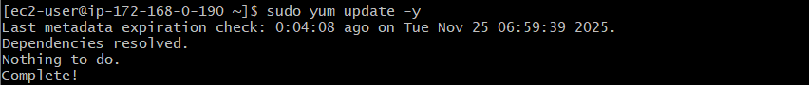
sudo yum install -y java-11-amazon-corretto
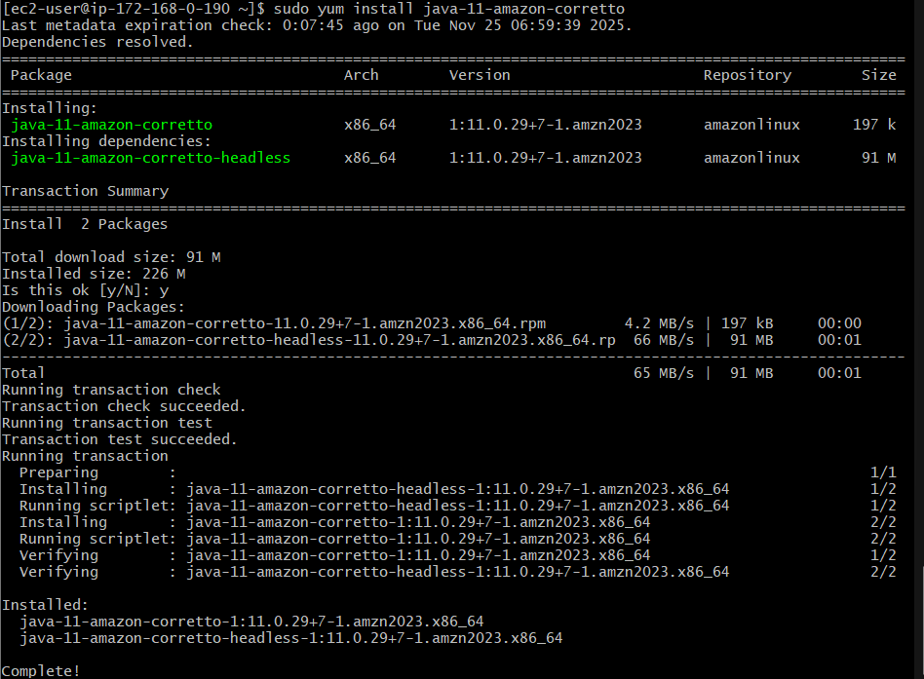
sudo yum install tomcat9 -y
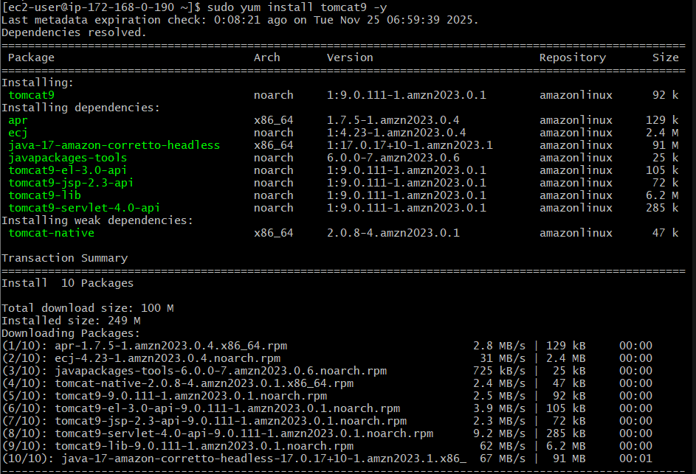

sudo systemctl enable tomcat9
sudo systemctl start tomcat9
sudo systemctl status tomcat9
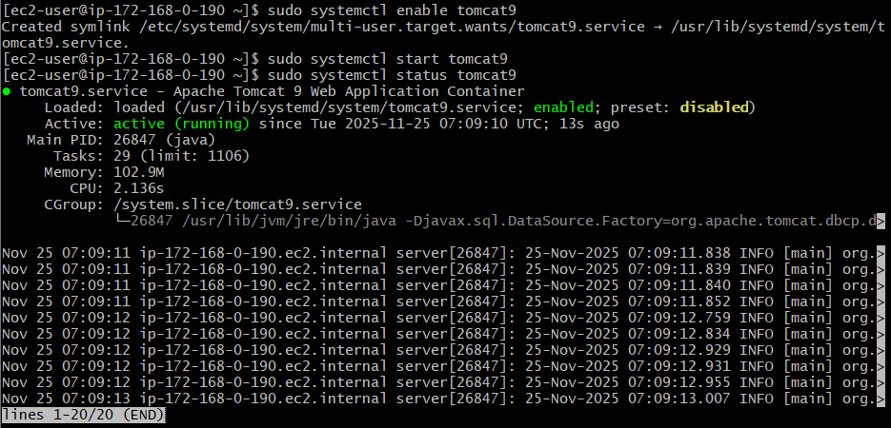

Deploy sample web app in tomcat :
cd /tmp
wget https://tomcat.apache.org/tomcat-9.0-doc/appdev/sample/sample.war
sudo cp sample.war /var/lib/tomcat9/webapps/
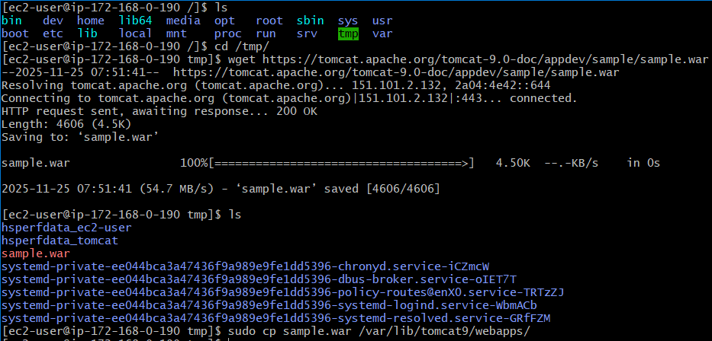
Restart tomcat :
sudo systemctl restart tomcat9
sudo systemctl status tomcat9
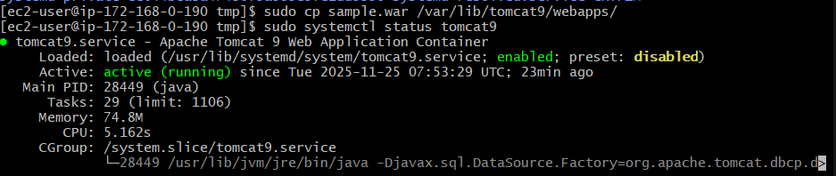
Test deployment : curl http://localhost:8080/sample
Output : Welcome to Private Tomcat Server
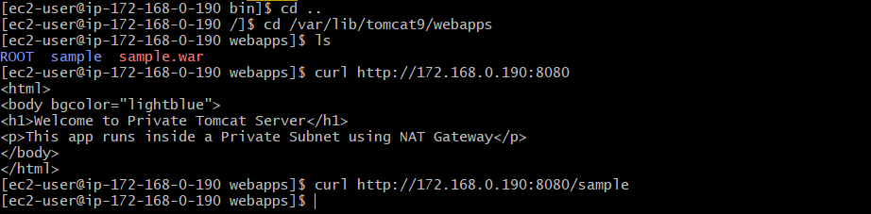
Test NAT Gateway Internet Access : ping -c 4 google.com

10. Configure VPC flow logs and store the logs in S3 and CloudWatch.
Create two flow logs for your VPC:
One that sends logs to CloudWatch Logs
One that sends logs to S3 Bucket

01. Create CloudWatch Log Group
Before creating the flow log, CloudWatch needs a log group.
Open CloudWatch
- Go to AWS Console
- Search CloudWatch
- Select CloudWatch
Create Log Group
- In left menu → choose Logs → Log groups
- Click Create log group
- Enter:
  - Log group name: vpc-flow-logs
- Click Create
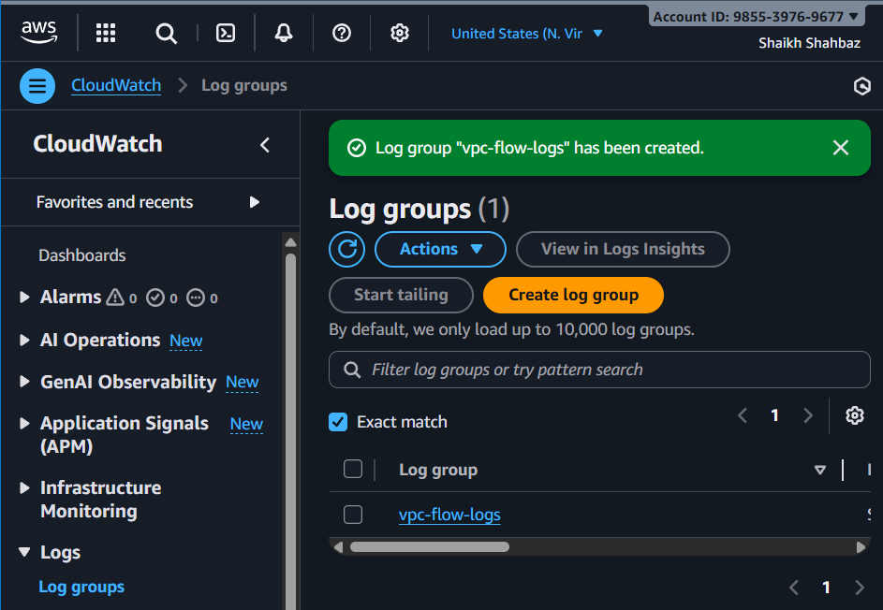

02. Create S3 Bucket for Flow Logs
Now create an S3 bucket to store raw flow log files.
Open S3
- Go to AWS console → S3 service
Create bucket
- Click Create bucket
- Enter:
  - Bucket name: vpc-flowlog-bucket-shahbazz
- Region: Same region as your VPC
- Keep all default settings
- Click Create bucket
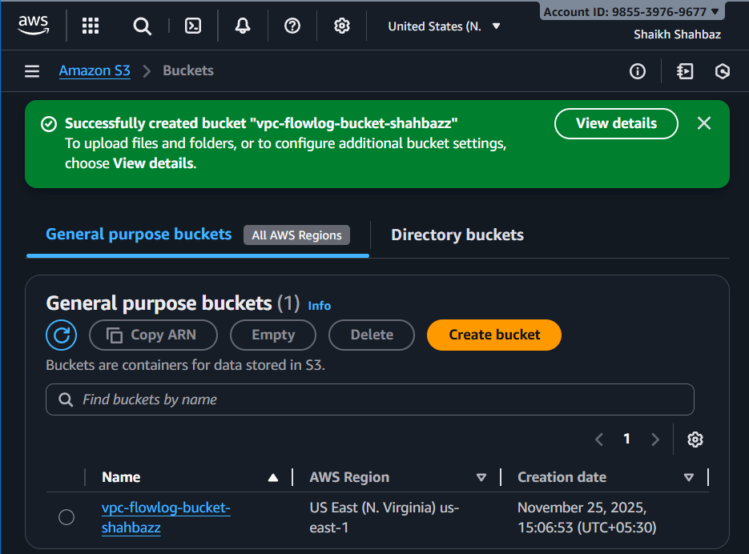

03. Create VPC Flow Logs (CloudWatch Destination)
Go to VPC Dashboard
- AWS Console → VPC
Select Your VPC
- From left menu click Your VPCs
- Select the VPC you created (my-vpc-01)
Create Flow Log for CloudWatch
- Select Create flow log
Configure Log Settings

Field | Value
Filter | ALL (captures Accept + Reject + All traffic)
Max aggregation interval | 10 minutes (default)
Destination | CloudWatch Logs
Log group | Choose vpc-flow-logs
IAM role | Click Create new role (AWS automatically creates one)
- Click Create flow log
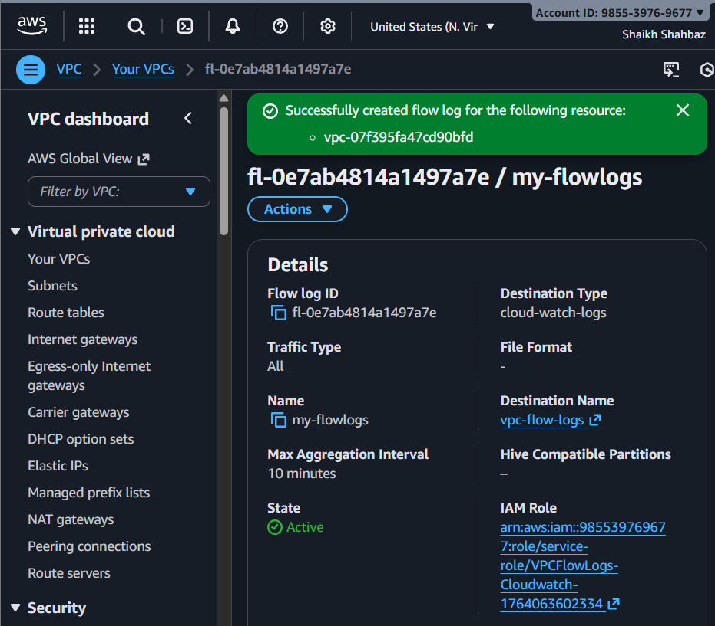

04. Create VPC Flow Logs (S3 Destination)
You must repeat the steps to create a second flow log.
Select the Same VPC Again
- VPC Console → Your VPCs
- Select my-vpc-01
Actions → Create Flow Log
Repeat same as before.
Configure for S3
This time change the Destination.
Field | Value
Filter | ALL
Max aggregation interval | 10 minutes
Destination | S3
S3 bucket ARN | Choose the bucket created earlier: arn : aws : s3 : : : vpc-flowlogs-bucket-shahbazz
- Leave rest as default.
- Click Create flow log
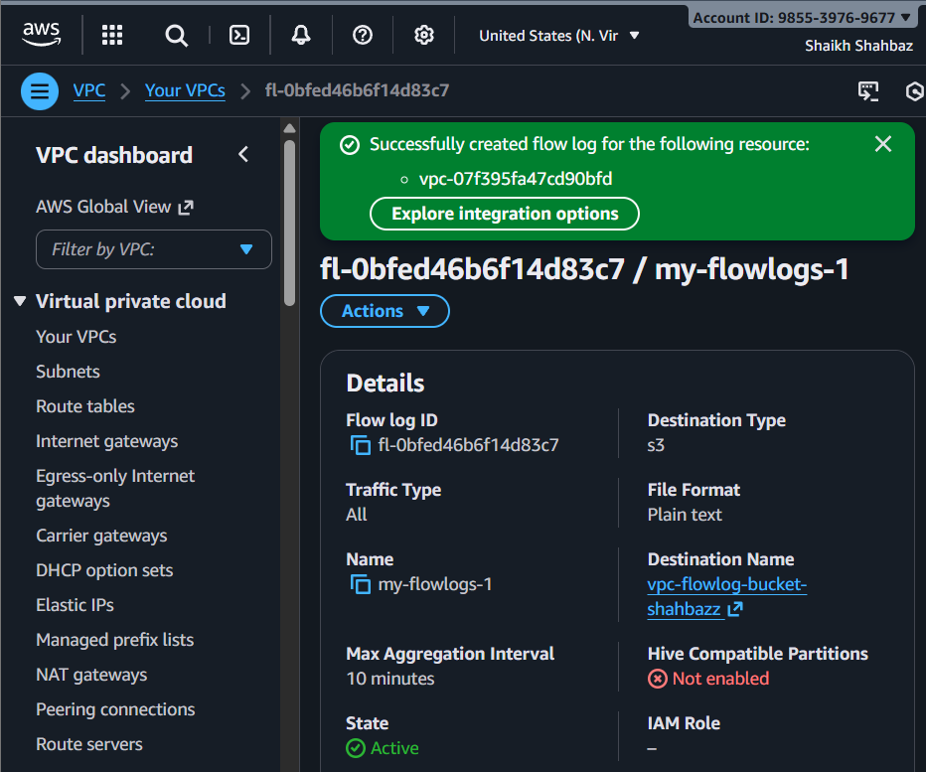

Flow Log #1
- Destination: CloudWatch
- Log Group: vpc-flow-logs
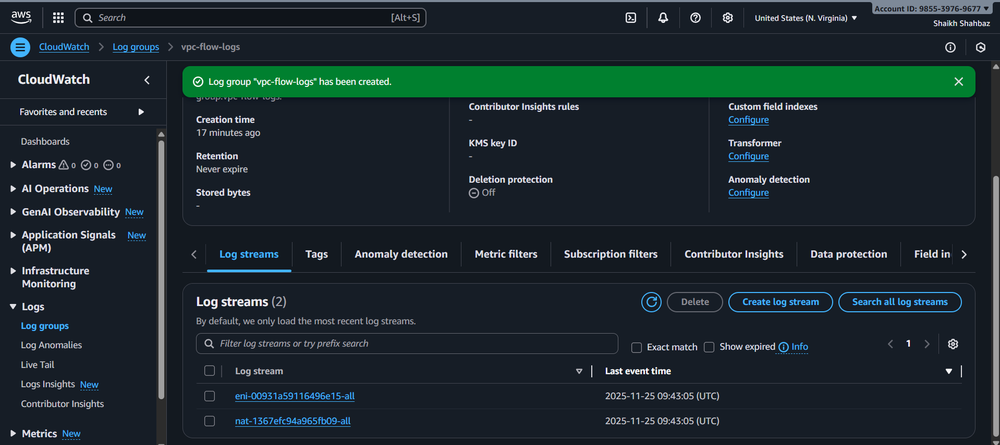

Flow Log #2
- Destination: S3
- Bucket: vpc-flowlogs-bucket-shahbazz
